2D SKETCH DESIGN USING FUSION 360
Record Submission

Name: V.TARUN

AIM:
To create a 2D mechanical profile using Autodesk Fusion 360 by applying sketch tools, circles, arcs, lines, trimming, mirroring, dimensions, and constraints according to the given engineering drawing.

SOFTWARE AND TOOLS REQUIRED
Software: Autodesk Fusion 360
Tools required:
Create Sketch
Circle Tool
Line Tool
Arc Tool
Sketch Dimension
Trim Tool
Mirror Tool
Constraint Tools
Finish Sketch

3. DESIGN DETAILS AND DIMENSIONS
The following dimensions are taken from the given engineering drawing.

S. No. Feature Dimension
1. Top outer circle Ø32 mm
2. Top inner circle Ø20 mm
3. Main body width reference Ø66 mm
4. Central opening reference Ø40 mm
5. Main curved sides R64 mm
6. Internal curve radius R6 mm
7. Side curves R20 mm
8. Small side curves R7 mm and R10 mm
9. Lower outer circle Ø20 mm
10. Lower inner circle Ø10 mm
11. Vertical dimensions 65 mm, 26 mm and 24 mm
12. Horizontal distance 47 mm

4. PROCEDURE
Step 1: Open Fusion 360
Open Autodesk Fusion 360 on the computer. Create a new design and save the file with a suitable name.
Step 2: Create a Sketch
Click on Create Sketch.
Select the XY plane.
The sketch workspace will open.
Step 3: Draw the Centreline
Select the Line tool.
Draw a vertical construction line through the origin.
Use this line as the centreline for the design.
The centreline helps maintain symmetry.
Step 4: Draw the Top Circle
Select the Circle tool.
Choose Centre Diameter Circle.
Place the centre on the vertical centreline.
Draw the outer circle with a diameter of 32 mm.
Draw another concentric circle with a diameter of 20 mm.
Use Sketch Dimension (D) to enter the exact diameters.
Step 5: Draw the Main Body
Use the Line and Arc tools to create the main body.
Connect the top circular portion to the middle section.
Draw the curved sides according to the given drawing.
Apply the specified radius of R64 mm.
Use Sketch Dimension to enter the required dimensions.
Step 6: Create the Side Portions
Draw the curved portions on the left and right sides.
Use the Arc tool to create the required curves.
Apply the radii R20 mm, R10 mm and R7 mm where indicated.
Maintain symmetry about the vertical centreline.
Step 7: Draw the Side Holes
Select the Circle tool.
Draw the circular outer portions at both sides.
Draw the inner holes according to the given drawing.
Position the hole centres 47 mm from the vertical centreline on each side.
Apply the required dimensions.
Step 8: Draw the Bottom Circle
Select the Circle tool.
Place the centre on the vertical centreline.
Draw the outer circle with a diameter of 20 mm.
Draw the inner circle with a diameter of 10 mm.
Align both circles concentrically.
Step 9: Draw the Central Opening
Use the Line and Arc tools to draw the shaped central opening.
Create the six-lobed internal profile as shown in the reference drawing.
Apply the required dimensions and the R6 mm radius.
Ensure that the opening is positioned at the centre of the design.
Step 10: Use the Mirror Tool
Select the geometry on one side of the vertical centreline.
Open the Sketch menu.
Select Mirror.
Select the geometry to mirror.
Choose the vertical construction line as the mirror line.
Click OK to create the symmetrical portion.
If both sides have already been drawn, do not mirror them again.
Step 11: Use the Trim Tool
Select the Trim tool or press the T key.
Click on unwanted portions of lines and arcs.
Remove overlapping segments carefully.
Ensure that the required outline remains intact.
Step 12: Apply Dimensions and Constraints
Press D to activate Sketch Dimension.
Enter the required diameters, radii and distances.
Apply Coincident constraints to connect geometry.
Apply Tangent constraints where required.
Check the symmetry of the design.
Step 13: Check the Sketch
Inspect the complete drawing.
Check whether all dimensions are correct.
Ensure that there are no unwanted lines or overlapping arcs.
Check that the required closed profiles are properly connected.
Step 14: Finish the Sketch
Click Finish Sketch.
Save the design.
Check the completed drawing.
Take a screenshot of the final sketch for record submission.

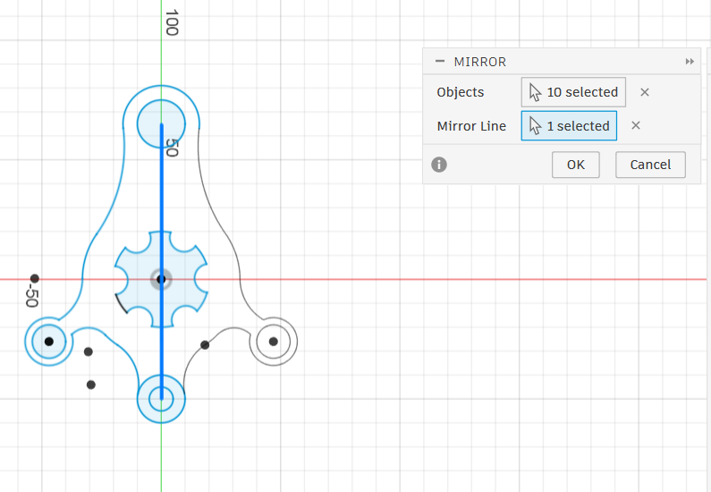5. RESULT
The 2D mechanical profile was created in Autodesk Fusion 360 using sketch tools, circles, arcs, dimensions, constraints, trimming and mirroring according to the given engineering drawing.
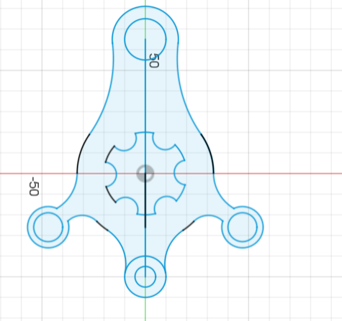

6. CONCLUSION
This exercise helped me understand the process of creating a 2D mechanical drawing using Autodesk Fusion 360. I learned to use sketch tools, create circles and arcs, apply dimensions and constraints, use the Mirror and Trim tools, and maintain symmetry in an engineering drawing.



